Your lab assignment involves putting together a presentation to show other students on how to perform titration. In other words, your presentation can be used to show other students (next term) how they can perform a titration by following your instructions and calculations.
To do this presentation, we are giving you the type of acid, acetic acid, the type of base, NaOH to be used, and you will use phenolphthalein as the indicator. You will use the data given to you to be used as an example of how to solve the mathematical calculations. At the end of your presentation, you will show the unknown concentration of the acetic acid (Molarity) and will also show the % mass/ vol of the Vinegar solution.
Everyone will use: Hydrochloric Acid reacting with Sodium Hydroxide
Part 1
- Purpose of a titration, what is titration and why do we perform a titration?
- Instrumentation- what are the instruments, glassware used when performing a titration.
- Chemicals and Procedures. What chemicals are needed? List and explain the procedures for this experiment.
- Observations and expectations- List the observations and write your expectations. This might include color change and when the equivalence point (endpoint) might be reached.
Part 2
- Calculations and Results. Show all your calculations and write your results, the Molarity of the acetic and the mass percent of the acetic acid.
- You will use the following for titration calculations:
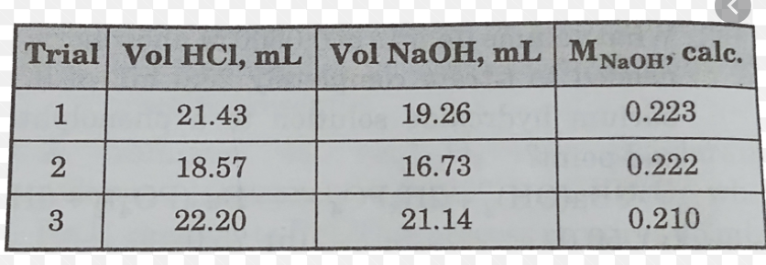
Be sure to show and explain the calculations and to use the numbers sent to you and export as a PDF before uploading.
Titration Power Point Example in the following PDF link.
This assignment should have both a title slide and a reference list that includes all the sources used. At least two scholarly sources should be used (your textbook can be one of the sources).
Here are some videos to help https://youtu.be/d1XTOsnNlgg

